**WEEK-2**

**MODULE -3**

**PL/SQL PROGRAMMING**

**SUPERSET ID:6407550**

**Exercise:1-Control Structures**

-values inserted to get output

INSERT INTO Customers (CustomerID, Name, DOB, Balance, LastModified)

VALUES (3, 'Elder Thomas', TO_DATE('1950-04-10', 'YYYY-MM-DD'), 2000, SYSDATE);

INSERT INTO Loans (LoanID, CustomerID, LoanAmount, InterestRate, StartDate, EndDate)

VALUES (2, 3, 8000, 6, SYSDATE, ADD_MONTHS(SYSDATE, 24));

INSERT INTO Customers (CustomerID, Name, DOB, Balance, LastModified)

VALUES (4, 'Wealthy Wanda', TO_DATE('1980-08-25', 'YYYY-MM-DD'), 20000, SYSDATE);

INSERT INTO Customers (CustomerID, Name, DOB, Balance, LastModified)

VALUES (5, 'DueSoon Dave', TO_DATE('1988-12-01', 'YYYY-MM-DD'), 3000, SYSDATE);

INSERT INTO Loans (LoanID, CustomerID, LoanAmount, InterestRate, StartDate, EndDate)

VALUES (3, 5, 7000, 7, SYSDATE, SYSDATE + 15);

**Scenario:1**

SET SERVEROUTPUT ON SIZE 1000000;

BEGIN

FOR rec IN (

SELECT c.CustomerID, l.LoanID, l.InterestRate

FROM Customers c

JOIN Loans l ON c.CustomerID = l.CustomerID

WHERE MONTHS_BETWEEN(SYSDATE, c.DOB) / 12 > 60

) LOOP

UPDATE Loans

SET InterestRate = rec.InterestRate - 1

WHERE LoanID = rec.LoanID;

DBMS_OUTPUT.PUT_LINE('Discount applied to LoanID: ' || rec.LoanID ||

', New Rate: ' || (rec.InterestRate - 1));

END LOOP;

COMMIT;

END;

/

**OUTPUT:**

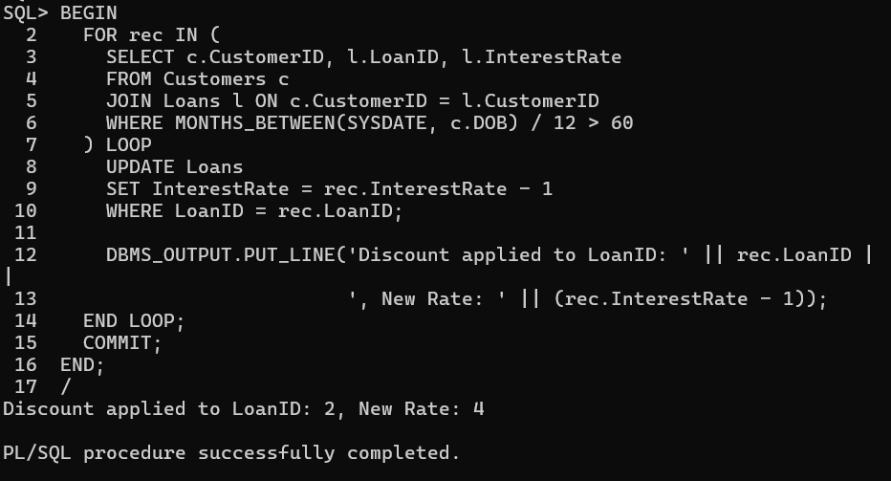

**Scenario:2**

SET SERVEROUTPUT ON;

BEGIN

FOR rec IN (

SELECT CustomerID, Name, Balance FROM Customers

WHERE Balance > 10000

) LOOP

DBMS_OUTPUT.PUT_LINE('Customer ' || rec.Name || ' (ID: ' || rec.CustomerID ||

') is eligible for VIP. Balance: ' || rec.Balance);

END LOOP;

END;

/

**OUTPUT:**

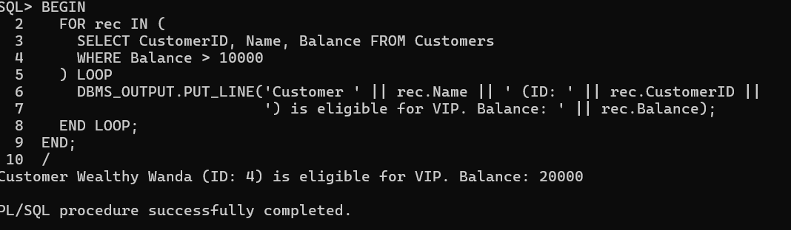

**Scenario:3**

SET SERVEROUTPUT ON;

BEGIN

FOR rec IN (

SELECT c.Name, l.EndDate

FROM Loans l

JOIN Customers c ON l.CustomerID = c.CustomerID

WHERE l.EndDate BETWEEN SYSDATE AND SYSDATE + 30

) LOOP

DBMS_OUTPUT.PUT_LINE('Reminder: Loan for ' || rec.Name ||

' is due on ' || TO_CHAR(rec.EndDate, 'DD-MON-YYYY'));

END LOOP;

END;

/

**OUTPUT:**

